1.1.1 Homework Solutions
- 1-6. See below.
  - y = x² − 6 and then .
  - Yes, reverse the order of the machines ( and then y = x² − 6) and use an input of x = 6.
- 1-7. See below.
  - 54
  - −7
  - 2
  - 2.93
- 1-8. See below.
  - 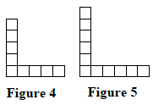
  - It grows by adding two tiles each time.
  - 1; The top and right tiles are removed, since the pattern is to add two tiles to expand each figure.
- 1-9. See below.
  - −59
  - 17
  - −72
  - 6
  - −24
  - −25
  - 25
  - −25
  - 7
- 1-10. See below.
  - y = 1
  - y = 3
  - y = 9

